Ideation Phase
Define the Problem Statements

Date | 28 September 2026
Team ID | SWTID-2026-6232
Project Name | AI WeatherWise API
Maximum Marks | 2 Marks

Customer Problem Statement Template:
The AI WeatherWise API is designed to address the difficulty users face in obtaining weather information together with simple explanations, recommendations, and conversational assistance in one system. The problem statements below focus on the user's perspective and the challenges they experience while using traditional weather services.

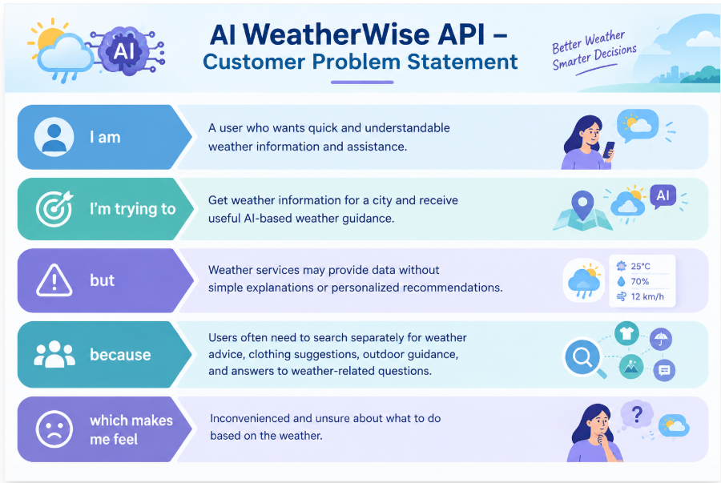

Problem Statement (PS) | I am (Customer) | I’m trying to | But | Because | Which makes me feel
PS-1 | A user who wants quick and understandable weather information | Get weather information for a particular city and understand the current conditions | Weather information is often presented mainly as raw weather data | Users may need additional information to understand what the weather conditions mean for their daily activities | Confused and requires additional searching
PS-2 | A user who wants personalized weather assistance | Get recommendations about clothing, outdoor activities, and things to carry based on the weather | Traditional weather services may mainly provide weather information without conversational assistance | Users need to search separately for weather-related advice and recommendations | Inconvenienced and wants a simpler solution

